Cultural Differences

ICT&SE-CB-S3

Vid Barbaro

Date : 21.12.2021
Version : 1
State : State
Author : Vid Barbaro
Contents
What is culture? 3
Material Culture 3
Social Culture 3
Ideological Culture 4
Understanding and overcoming cultural differences 4
Personal example of cultural difference 5
How would I act in the future if I knew I had to work with people from different cultures? 5
Improvements made in our group considering cultural differences 6

What is culture?

Culture is a system of understandings that describe how the members of a society customarily behave, it is a way of life for a particular society. Culture distinguishes one human group from another. In a way it is a pattern of behavior and thinking that people in social groups learn, create and share.
People who share a common culture (rules of behavior and social organization) can constitute a society.
Anthropologists categorized culture into 3 broad categories: material, social and ideological. The 4th category would be arts.

Material Culture

Material culture can be found in the objects and architecture that surround people. It includes the usage, consumption, creation, and trade of objects as well as behaviors, norms, and rituals that the objects create or take part in.
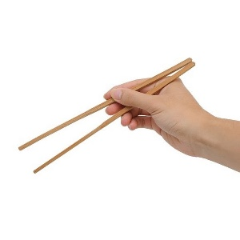

Social Culture

Social Culture is a complex set of meaning, habits, values, and behaviors adopted by one or more social formations.
Forms of social interaction and organization: bonds by kinship and marriage, work duties and economic position, political position. Important factors include age and gender.
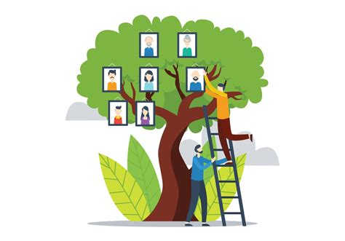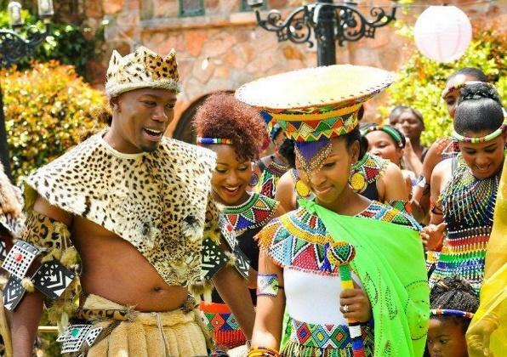

Ideological Culture

Ideologic culture can be split into 3 parts.
Beliefs – understanding of how the world works and how to respond to actions of others and their environments.
Values – differentiate right from wrong or good and bad
Ideals – models for what people hope to achieve in life. Could be based on religious and/or secular beliefs and values
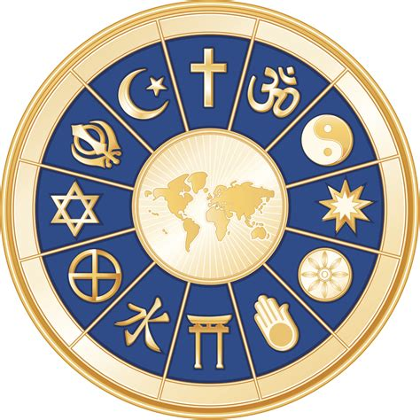

Understanding and overcoming cultural differences

In the 21st century the world is dominated by globalization, therefore intercultural connection is inevitable. While this brings a lot of advantages like increased trade, higher standards of living and diversity, is also poses some challenges like cultural barriers.
These are some examples of how to correctly handle cultural differences:
- Be self-aware, acknowledge differences – try to educate yourself about your co-worker’s background, share information about your own culture and be open to a dialogue.
- Do your research, learn about other cultures – understanding the reasoning behind one’s actions can reduce ‘wrong labeling’ and lead to a more effective collaboration and communication process
- Be open-minded, adaptable, respectful – find what you have in common and learn how to make the best use of each unique characteristic. Respect the fact that others have distinct core values from your own
- Reconcile, communicate better, be empathetic – communication is an essential aspect in the cultural exchange process. Language barriers are the most common cause of misinterpretations. Try to be as clear as possible and make sure your message was received correctly by the listener

Personal example of cultural difference

When I was 14 years old, I was one of the students chosen to go on a weeklong Erasmus exchange to Valencia, Spain.
Since I was relatively young, I didn’t have much contact with other cultures, I was born and raised in a small town in Croatia where there aren’t many different cultures present. A big majority of the citizens come from the same religious background and were raised by similar principles. In Croatia as in many other eastern countries when meeting someone for the first time, no matter if it is a friend of a friend or a business associate, the 2 parties always shake hands and make according introductions. I expected nothing different for my first encounter with the Spanish family that was hosting me for the Erasmus exchange, but to my surprise and slight discomfort there was hugging and kissing each other on cheeks involved as first introductions were made. Spending 7 days there I found out that that was a normal way to greet people who weren’t considered your superiors or business associates. I have also noticed that the Spanish students were a lot less formal towards their teachers compared to the teacher-student relations in Croatia.
As a conclusion I just thought to myself it is different cultures, upbringings, and societies. After getting a lot more experienced and acquainted with other cultures in the world by traveling, doing student exchange programs and language courses in different countries I can safely say that patterns emerge. The first pattern I saw (in Europe) is that the southern/warmer countries are occupied by more physically affectionate and ‘touchy’ people/cultures whilst the northern/colder countries tend to be more distant and reserved. I could notice the same thing while visiting some friends in the southern/seaside part of Croatia compared to the northern/mountain part, the same patterns emerged but the differences were not so shocking or drastic since it is the same country and same ideology. Of course there is lots of exceptions to these observations because every person is different and we cannot label someone just because they live in a certain area.

How would I act in the future if I knew I had to work with people from different cultures?

Personally, I don’t see why working with someone that has a different culture than myself would pose any problems. I find it interesting to learn about different cultures, whether it is through travel, language, food, or beliefs. The only real problem as I see that could cause problems in the workplace with different cultures is language differences. Even though there are temporary solutions to that like using Google Translate or trying to communicate with hand gestures unfortunately in a complex workplace that is not the solution. In the 21st century English is a universal language and a big majority of people with higher education can speak it as well as a lot of people without higher education.
So to prepare myself to work with people with vastly different cultures than mine I would first do a bit of research on their culture and what is considered appropriate or inappropriate behavior. While that could achieve positives it is also not a definite solution. As I mentioned before, we shouldn’t label people based on the culture or country they grew up in because they could have different ideas or maybe even not agree with every aspect of their culture, so in a way you can’t prepare yourself and you cannot expect to work successfully with every co-worker you meet. The key is communication and trying to understand their view on different things even if you don’t agree with it. The solution is finding middle ground and cooperating to make the workplace and atmosphere enjoyable for everyone involved, and that everyone feels accepted.

Improvements made in our group considering cultural differences

Since all of the members from our group are from Eastern European countries we share similar cultures and beliefs. The workplace/study etiquette is very similar and didn’t need major adjustments. We do however on certain occasions ask each other about differences in the adolescence life and our growing up, and while finding lots of similarities there are also noticeable differences. We share similar food and recipes with similar names so that was something a few of us connected over, cooking traditional Eastern European/Balkan food.

